**Tarea: Describe las imágenes usa el vocabulario y sigue el ejemplo.**

0[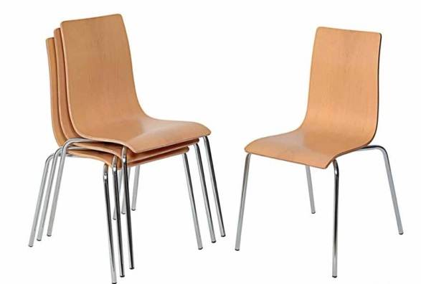](http://www.google.com/url?sa=i&rct=j&q=&esrc=s&source=images&cd=&cad=rja&uact=8&ved=0ahUKEwiHs8mq44vLAhVFMSYKHYXbDVMQjRwIBw&url=http://www.adamobili.com.ar/index.php?option%3Dcom_content%26view%3Dcategory%26layout%3Dblog%26id%3D46%26Itemid%3D66&bvm=bv.114733917,d.eWE&psig=AFQjCNEQK6xQEDfOQ7TMvpD3q7sQYyqxGQ&ust=1456244408523932)

**Example: Hay cuatro sillas beige, de metal y cómodas.**

**There are four beige chairs , made of metal and comfortable.**

1

[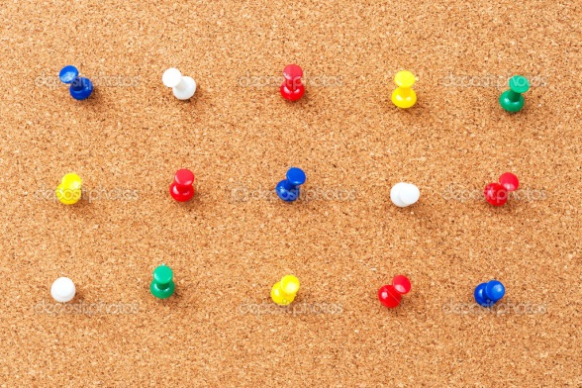](http://www.google.com/url?sa=i&rct=j&q=&esrc=s&source=images&cd=&cad=rja&uact=8&ved=0ahUKEwi2m-qE44vLAhUB6iYKHUxpApkQjRwIBw&url=http://sp.depositphotos.com/23893607/stock-photo-group-of-thumbtacks.html&psig=AFQjCNHkf_JXyb-myNHXCIqO6UJlDH9xWg&ust=1456244335815894)

2. [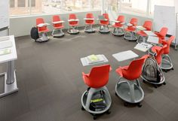](https://www.google.com/url?sa=i&rct=j&q=&esrc=s&source=images&cd=&cad=rja&uact=8&ved=0ahUKEwjdqM_c44vLAhVGOCYKHc6DDxwQjRwIBw&url=https://www.pinterest.com/explore/school-furniture/&bvm=bv.114733917,d.eWE&psig=AFQjCNFLeoes8GvyOEOaeuCmE-Kjv4q8kw&ust=1456244518985471)

3. [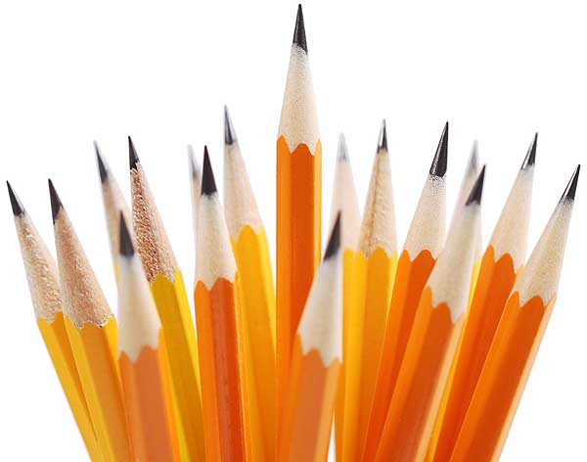](http://www.google.com/url?sa=i&rct=j&q=&esrc=s&source=images&cd=&cad=rja&uact=8&ved=0ahUKEwjR_KL044vLAhWC4SYKHezgA1IQjRwIBw&url=http://www.baabeta.com/product-category/pencilsrubbersharpner/&bvm=bv.114733917,d.eWE&psig=AFQjCNHFwwRzV1FRkM9m4XeCJzQ-hCRnMA&ust=1456244556290858)

4. [](https://www.google.com/imgres?imgurl=http://images4.fanpop.com/image/photos/24100000/Colored-pencils-pencils-24173421-2560-1600.jpg&imgrefurl=http://www.dozdrapeci.tk/wall/colored-pencils-wallpaper/&h=1600&w=2560&tbnid=cr4dNX3HXCFPbM:&docid=PpPG1SUw0PcMgM&ei=yzXLVpn5OozCmwHl4pB4&tbm=isch&ved=0ahUKEwjZiv7s44vLAhUM4SYKHWUxBA8QMwhgKCcwJw)

5. [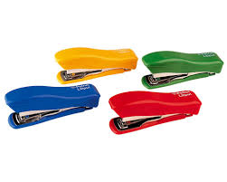](https://www.google.com/url?sa=i&rct=j&q=&esrc=s&source=images&cd=&cad=rja&uact=8&ved=0ahUKEwjYh4Ge5IvLAhUJ2SYKHXOkALMQjRwIBw&url=https://www.carlin.es/GRAPADORA_PETRUS_LILIPUT_200&bvm=bv.114733917,d.eWE&psig=AFQjCNEwdGqRQRXlLRS1ZLgl-VxYq0vDbA&ust=1456244650964685)

6. [](http://www.google.com/url?sa=i&rct=j&q=&esrc=s&source=images&cd=&cad=rja&uact=8&ved=0ahUKEwjyotez5IvLAhUM8CYKHZ8mBrcQjRwIBw&url=http://it.dreamstime.com/fotografia-stock-libera-da-diritti-libri-colorati-voluminosi-image3526787&bvm=bv.114733917,d.eWE&psig=AFQjCNHb4a2IHl5PnZZtZfNglIYu-AeDpg&ust=1456244697991049)

7. [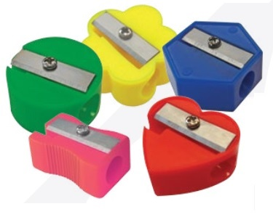](http://www.google.com/url?sa=i&rct=j&q=&esrc=s&source=images&cd=&cad=rja&uact=8&ved=&url=http://klika.mx/texto.php?key%3Dlos-10-articulos-que-utilizaste-en-la-escuela&bvm=bv.114733917,d.eWE&psig=AFQjCNFRNvxWO27XnlyXdeBVgyHqBiZF8A&ust=1456244764780428)

8. [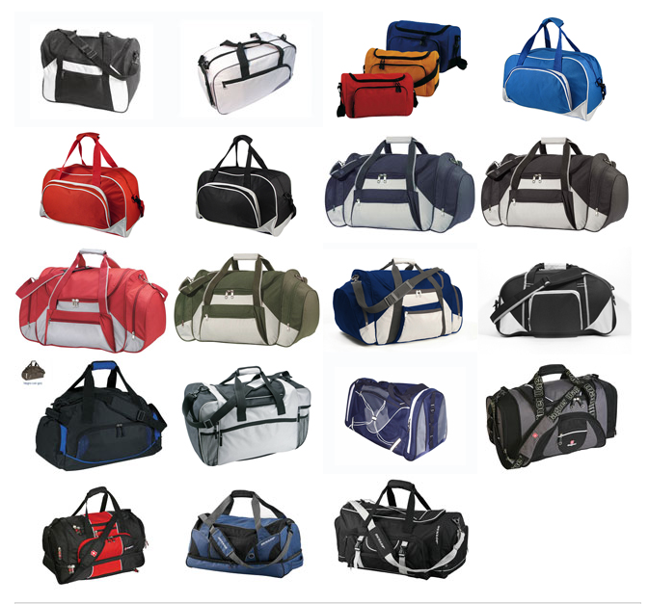](http://santiago.all.biz/bolsos-deportivos-g15785)

9 [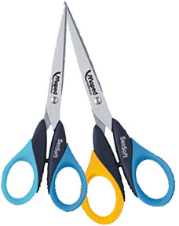](http://www.google.com/url?sa=i&rct=j&q=&esrc=s&source=images&cd=&cad=rja&uact=8&ved=0ahUKEwiLwcjO5YvLAhVKSSYKHTMKDdcQjRwIBw&url=http://www.tiendarincondelzurdo.com/TIJERAESCOLARMAPEDSENSOFT&bvm=bv.114733917,d.eWE&psig=AFQjCNE0GwBNjq8EfGeT6DHTQFfR1G4oYQ&ust=1456244997862810)

10. 