Proyecto Comida Hispana
- Students will cook a dish from a country where Spanish is primary Language.
- Students will bring a sample of the dish to the classroom on May 16th of 2016. (due date)
- They can work individually or in pairs.
- Students will not share food at the school, they can eat the food that they fix at home under parents supervision.
- Students must present evidence of them cooking the dish, for example:
Pictures of them cooking or a video clip when they are cooking or a slide show with the pics or videos. If they do not want to be on the pictures or they are not allowed to, they will record the process and add audio in Spanish using their voices. See examples below
- The recipe must be in Spanish
- The name of the dish, the country, the ingredients and steps must be presented on a poster.
Rubrics:
- Poster (30 points)
- Slide show, pics , videos or any technological evidence (30 points)
- Presenting the dish to the class and explaining how students fixed it (40 points)

Example of the Poster
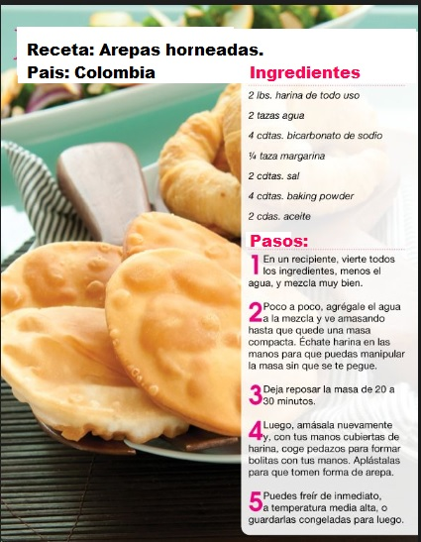
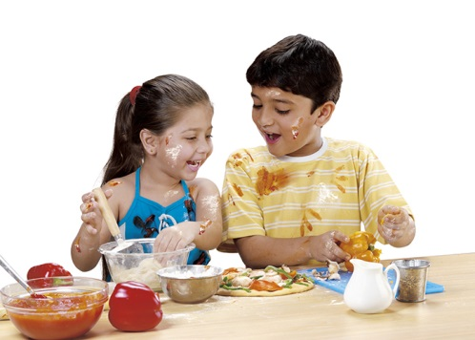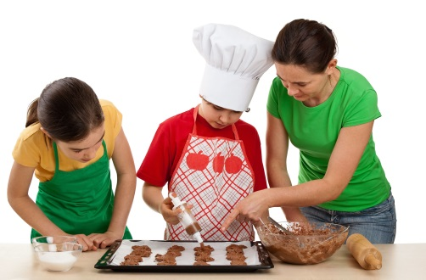
Example of the video: https://www.youtube.com/watch?v=FoPt4wiXJeY

