Marzo 25 de 2015
Go to this link.
http://www.aprenderespanol.org/verbos/preterito-imperfecto.html
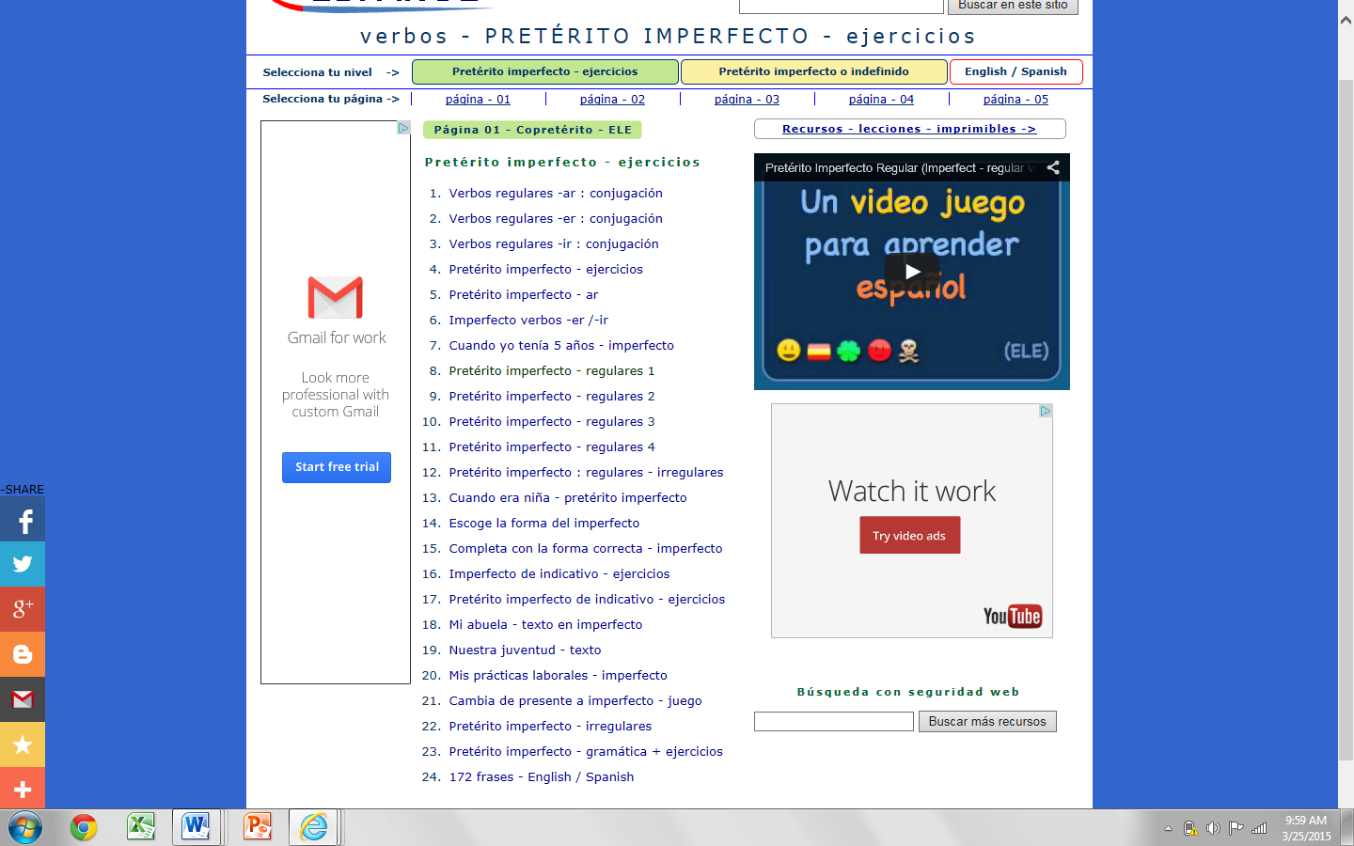

From the list above Practice imperfect working with the exercises #:
8,9,10.15,16,17,18.

