1. **Study the Verb SER**

**Go to** <http://www.youtube.com/watch?v=44SbO2nGQSA>

1. **Write the profession below the picture**

[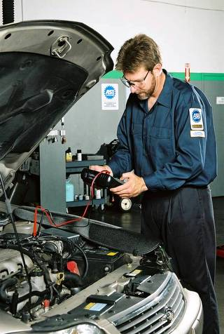](http://www.google.com/url?sa=i&rct=j&q=&esrc=s&frm=1&source=images&cd=&cad=rja&docid=MQLvu1Iv839-6M&tbnid=50v8hS5-U1Nn4M:&ved=0CAUQjRw&url=http://conacyemtoluca.wordpress.com/2012/06/17/taller-mecanico-fernandez/&ei=U3U2UrXfN-644APvmIF4&bvm=bv.52164340,d.dmg&psig=AFQjCNHp3mjec7z8HghxBCpoWT5OnXYRkw&ust=1379387082575017) [](http://www.google.com/url?sa=i&source=images&cd=&cad=rja&docid=95JDiOP1-x6t8M&tbnid=LT23YUOT5RA93M:&ved=0CAgQjRwwAA&url=http://www.mdzol.com/nota/324631/&ei=GXo2UqrVNbXh4AO57YAw&psig=AFQjCNGDQLOXcScuRH_cd8jaSZ197eyRhQ&ust=1379388313909937) [](http://www.google.com/url?sa=i&rct=j&q=&esrc=s&frm=1&source=images&cd=&cad=rja&docid=rnsoHHXOU66hBM&tbnid=B3V-gViQsMiQrM:&ved=0CAUQjRw&url=http://www.deadline.com/tag/the-borgias/&ei=inU2UtaZNKvl4APS-ICgCw&bvm=bv.52164340,d.dmg&psig=AFQjCNFO3WOQRb0tlJ7HdRJFG_6VOtVkgg&ust=1379387128755835)

[](http://www.google.com/imgres?hl=en&biw=1242&bih=591&tbm=isch&tbnid=-_jsUKfQaa3Y1M:&imgrefurl=http://madinperu.wordpress.com/page/2/&docid=HesPrP3adsOYXM&imgurl=http://madinperu.files.wordpress.com/2012/09/dsc_0101.jpg&w=2362&h=1575&ei=GXY2UsGpGdSw4AOayYHYCQ&zoom=1&ved=1t:3588,r:35,s:0,i:192&iact=rc&page=3&tbnh=178&tbnw=272&start=35&ndsp=16&tx=109.81819152832031&ty=83.3636474609375)[](http://www.google.com/url?sa=i&rct=j&q=&esrc=s&frm=1&source=images&cd=&cad=rja&docid=yazfmmOUZxoTuM&tbnid=I7-caCiMYXn3IM:&ved=0CAUQjRw&url=http://azulchina.blogspot.com/2008_02_01_archive.html&ei=tnY2Ur-6Dq_k4AOh_IG4AQ&psig=AFQjCNFWVKoHh3I2UGTtzS84ezJ8LwkpDw&ust=1379387426777051)

[](http://www.google.com/imgres?hl=en&biw=1242&bih=591&tbm=isch&tbnid=XW68Ee4xCvoEtM:&imgrefurl=http://www.logrosperu.com/&docid=fCFXkxPRHNQltM&imgurl=http://www.logrosperu.com/images/stories/revista/instituto/idat/secretariado-ejecutivo.jpg&w=500&h=350&ei=7HY2UqS_KbOz4AOg84GIBw&zoom=1&ved=1t:3588,r:93,s:0,i:375&iact=rc&page=6&tbnh=178&tbnw=254&start=80&ndsp=16&tx=117.0909423828125&ty=81)[](http://www.google.com/url?sa=i&rct=j&q=&esrc=s&frm=1&source=images&cd=&cad=rja&docid=aAMPSLQtvFpuPM&tbnid=VdGZu-bw0Tv6oM:&ved=0CAUQjRw&url=http://blog.manqv.com/sepa-como-ser-un-buen-gerente-para-su-empresa/&ei=XHc2UpH5IsXl4APT2oCQCw&psig=AFQjCNEWODD6YjuoyX8q5F3JYBLBljxmkg&ust=1379387571151713)

[](http://www.google.com/url?sa=i&rct=j&q=&esrc=s&frm=1&source=images&cd=&cad=rja&docid=jLkO8QizwwhI8M&tbnid=mswUhLMf-PTEoM:&ved=0CAUQjRw&url=http://www.123rf.com/stock-photo/accountant.html&ei=inc2UsK5AY_-4APz-ICIAw&psig=AFQjCNH-hflqnBTW5yB5UraYRNlaxnTQ7g&ust=1379387652481230)[](http://www.google.com/url?sa=i&rct=j&q=&esrc=s&frm=1&source=images&cd=&cad=rja&docid=br40e2zuKS8eBM&tbnid=WvHEJ1ctIgjq8M:&ved=0CAUQjRw&url=http://www.gazzettadellavoro.com/concorso-per-psicologo-emilia-romagna/106265/&ei=yXc2Ut36LMrl4AO-oYDICw&psig=AFQjCNG-ptqIqL0NDYo1XHVFdqh4QZ_LKA&ust=1379387705094638)

[](http://www.google.com/url?sa=i&rct=j&q=&esrc=s&frm=1&source=images&cd=&cad=rja&docid=ce8DkJ4LmXd0AM&tbnid=WE09HcNHfo3ZmM:&ved=0CAUQjRw&url=http://www.imagui.com/a/dibujos-marineros-c5ep7Ek7M&ei=LXg2UpipHbiz4APkt4HICQ&psig=AFQjCNGc1F2z8n__A4aZ0tQF4iQ-qr5Zvg&ust=1379387759708025)

[](http://www.google.com/url?sa=i&rct=j&q=&esrc=s&frm=1&source=images&cd=&cad=rja&docid=L83IYqDH6UivIM&tbnid=vQYq-bNd_fjYWM:&ved=0CAUQjRw&url=http://es.123rf.com/photo_15586763_los-jovenes-y-las-pequenas-empresas-mujer-hispana-en-el-trabajo-como-disenadora-de-moda-y-sastre-mir.html&ei=MHk2UrzpNuL84AOUr4C4BA&bvm=bv.52164340,d.dmg&psig=AFQjCNFyBIiD8DFAkyDhtqJvNHVZklZz8Q&ust=1379388038990676)

[](http://www.google.com/url?sa=i&rct=j&q=&esrc=s&frm=1&source=images&cd=&cad=rja&docid=qcrG0Z2SnfNueM&tbnid=fl2otaMUK5VfaM:&ved=0CAUQjRw&url=http://www.bridgetowntrucking.org/tips-on-hiring-professional-truck-driver/&ei=gHk2UvDPINHe4AP9v4HQBg&bvm=bv.52164340,d.dmg&psig=AFQjCNE0P-FLfuG7eDXkTWmkagMDcuFXlw&ust=1379388133331269)

[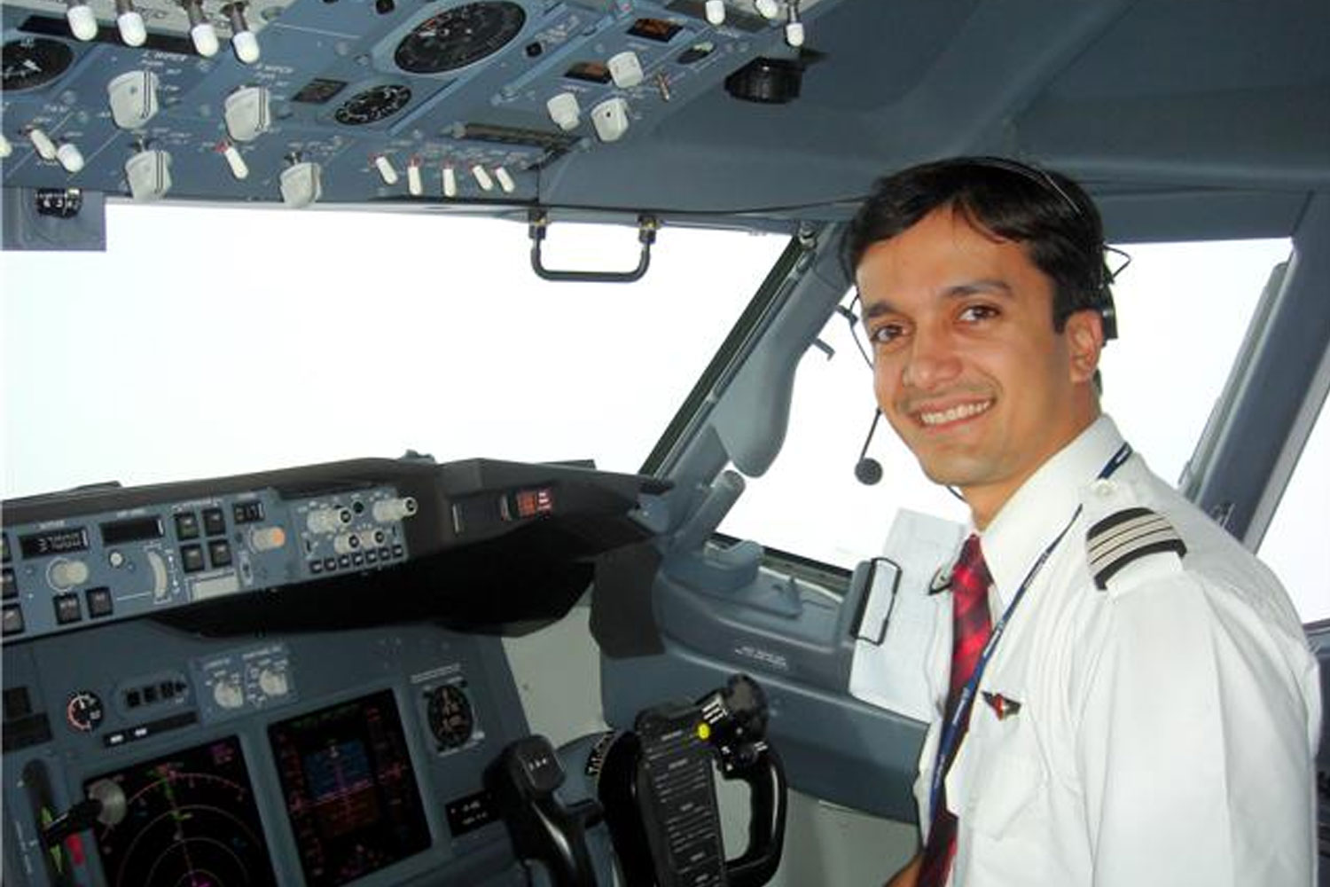](http://www.google.com/url?sa=i&source=images&cd=&cad=rja&docid=KAjdyo4OaLcSeM&tbnid=-X_OS0GxwCC3pM:&ved=0CAgQjRwwAA&url=http://salaryinfohq.com/commercial-pilot/the-benefits-of-commercial-pilot-training/&ei=pnk2Uqr1NrTG4AO6zYGIBA&psig=AFQjCNG9umfjKEkAKjkKufhi4ObELWQWgQ&ust=1379388198930057)

[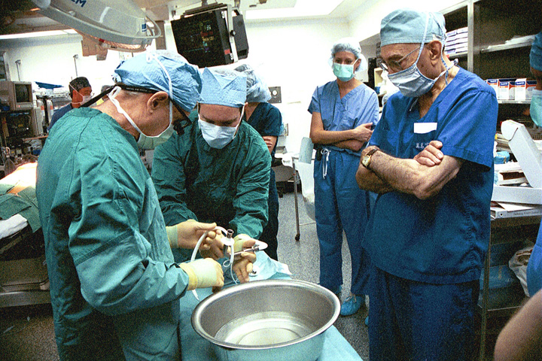](http://www.google.com/url?sa=i&rct=j&q=&esrc=s&frm=1&source=images&cd=&cad=rja&docid=TVzTpkEoA6_dfM&tbnid=IXqZmhUOrhQC-M:&ved=0CAUQjRw&url=http://medicablogs.diariomedico.com/desdeelpuente/tag/cirujano/page/3/&ei=G3s2UvWSPJjd4APh0ICoAQ&psig=AFQjCNE6yUuRYtx1oyxcBV2kEgHyIssm4Q&ust=1379388537208858)[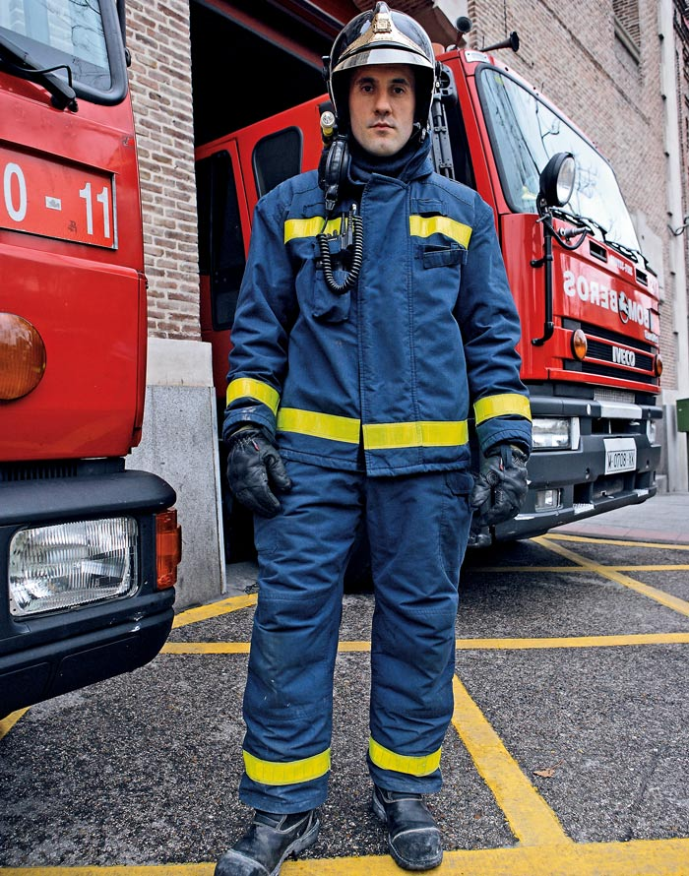](http://www.google.com/url?sa=i&rct=j&q=&esrc=s&frm=1&source=images&cd=&cad=rja&docid=ySjb0RSTyrTN3M&tbnid=2_BQr042xcYBrM:&ved=0CAUQjRw&url=http://www.elpais.com/especial/retrato-de-un-pais/bombero.html&ei=RXs2UsrUFfKj4AOmjID4Bw&psig=AFQjCNGEIe-R2WJ4SF06uvJbmciUHDCo4Q&ust=1379388609538648)[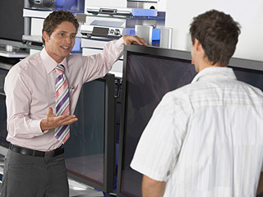](http://www.google.com/url?sa=i&rct=j&q=&esrc=s&frm=1&source=images&cd=&cad=rja&docid=nnWCWzzKyPvpHM&tbnid=401YwaX4mbaGwM:&ved=0CAUQjRw&url=http://www.altonivel.com.mx/9268-como-elegir-buenos-vendedores.html&ei=1Hs2UsLYDJLl4AOM4ICABg&psig=AFQjCNEx_gU7S48Hv9GfC1ay0v4VDaLpvQ&ust=1379388714146590)[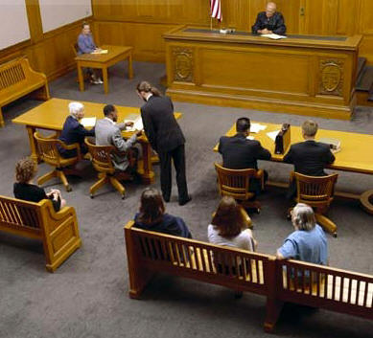](http://www.google.com/url?sa=i&source=images&cd=&cad=rja&docid=M653_8bdYVvi1M&tbnid=2sTdTzZX9xzHwM:&ved=0CAgQjRwwAA&url=http://www.austin-dwilawyer.com/&ei=C3w2UqTwH6eg4APL24HYDQ&psig=AFQjCNH3m1fm7j3s5z7EUb7cLTT45Wr2Vw&ust=1379388811570923)[](http://www.google.com/url?sa=i&rct=j&q=&esrc=s&frm=1&source=images&cd=&cad=rja&docid=V94pthuKgSLlwM&tbnid=MdQYetrgk0ZhCM:&ved=0CAUQjRw&url=http://depositphotos.com/5785638/stock-illustration-Builder-man-with-derby-tool-building-a-brick-wall.html&ei=hXs2Up7pOJa-4AOk7oHYBw&psig=AFQjCNFl8enyOll_ZGiCOJAfKT50Q5ffDQ&ust=1379388670308889)[](http://www.google.com/url?sa=i&rct=j&q=&esrc=s&frm=1&source=images&cd=&cad=rja&docid=14hWxXrLzxc1kM&tbnid=j4j5_XxqsvW56M:&ved=0CAUQjRw&url=http://eusouportugues.com/policia-do-porto-paga-4e-para-um-homem-alimentar-a-familia-e-nao-sofrer-acusacao/&ei=m3w2Up3bAdWr4APKyYDYCw&psig=AFQjCNHTm6YJBcAmp5pXo-rqdRNVCmr6Rg&ust=1379388952054251)[](http://www.google.com/url?sa=i&source=images&cd=&cad=rja&docid=e2R9olivJ5F4-M&tbnid=UpgMCSyuGFJrbM:&ved=0CAgQjRwwAA&url=http://invisalignreviewsite.com/&ei=PHw2UreTE4L54AOtsIDABA&psig=AFQjCNFfwLzvXNqgIzrt4NUNEFDUsYG0Vg&ust=1379388860341744)[](http://www.google.com/url?sa=i&rct=j&q=&esrc=s&frm=1&source=images&cd=&cad=rja&docid=jON26jSmejG1nM&tbnid=gq_FDHGMXf5q0M:&ved=0CAUQjRw&url=http://www.slate.com/articles/life/food/2012/10/martha_stewart_s_cooking_school_reviewed_a_quietly_revolutionary_alternative.html&ei=bXw2UsqaDNKx4AP20IGQDA&psig=AFQjCNHndtEIvacBFDn5jB7BVZ1tONn7AQ&ust=1379388897987140)

[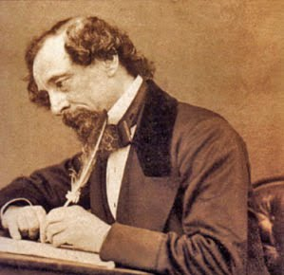](http://www.google.com/url?sa=i&rct=j&q=&esrc=s&frm=1&source=images&cd=&cad=rja&docid=uxI6OHaEbUKb7M&tbnid=n-C3_FZRNqlJ5M:&ved=0CAUQjRw&url=http://elbustodepalas.blogspot.com/2010/07/curiosidades-que-desconoces-sobre_23.html&ei=6Xk2UtrvB4384APFooCYCA&psig=AFQjCNFv0RGCRB1mEu1NPRDeOT-MghY_Yg&ust=1379388231785417)[](http://www.google.com/url?sa=i&source=images&cd=&cad=rja&docid=95JDiOP1-x6t8M&tbnid=LT23YUOT5RA93M:&ved=0CAgQjRwwAA&url=http://www.mdzol.com/nota/324631/&ei=GXo2UqrVNbXh4AO57YAw&psig=AFQjCNGDQLOXcScuRH_cd8jaSZ197eyRhQ&ust=1379388313909937)[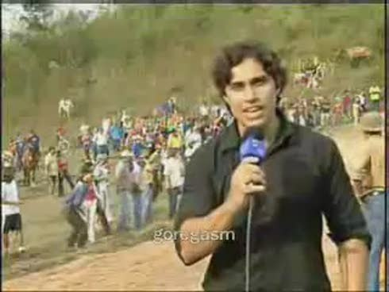](http://www.google.com/url?sa=i&rct=j&q=&esrc=s&frm=1&source=images&cd=&cad=rja&docid=d_W1UylLD87lIM&tbnid=abK7tWDDzb9-eM:&ved=0CAUQjRw&url=http://www.radio.neteando.net/trabajos/reportero/&ei=1no2UqDYM7W24AOol4CABg&psig=AFQjCNHeD1E2lnBs7_ArlysPkptN_kGFPg&ust=1379388499275977)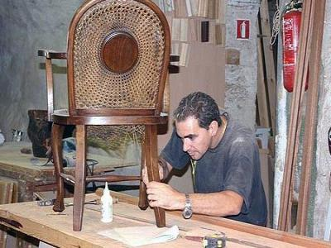[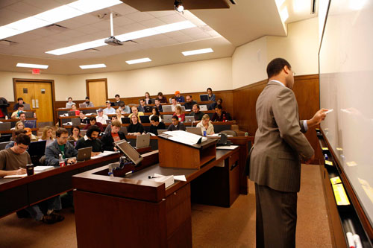](http://www.google.com/url?sa=i&source=images&cd=&cad=rja&docid=bieJ_uWTpO-npM&tbnid=O4NpogKXwFuR7M:&ved=0CAgQjRwwAA&url=http://www.utexas.edu/law/about/photogallery/index.php&ei=D302UvuxJbfH4AOB34HYDQ&psig=AFQjCNE8fT9bBz_M6sxFWZ-QJwavuawgOw&ust=1379389071640914)

[](http://blogs.salleurl.edu/arquitectura/files/2012/07/Ingeniero-edificación.gif)

[](http://www.google.com/url?sa=i&rct=j&q=&esrc=s&frm=1&source=images&cd=&cad=rja&docid=H5GFDIto6Zb5YM&tbnid=ffk2-qofKunK9M:&ved=0CAUQjRw&url=http://www.123rf.com/photo_15125876_illustration-of-a-pretty-blonde-architect-woman-in-black-suite-with-a-building-blueprint-on-backgrou.html&ei=vX02UsyGFZPH4AOY9YCoBQ&psig=AFQjCNE5eZcoGUQ4tRWggbZAiQkvrgBUVg&ust=1379389234885082)

[](http://www.google.com/url?sa=i&source=images&cd=&cad=rja&docid=WgHY1cZzzruLHM&tbnid=SfDVNErwSOSf0M:&ved=0CAgQjRwwAA&url=http://www.blog.inmogul.com/2013/06/04/soldier-iraq-poem-life-loss-jevonte-lockhart/&ei=r3g2UpTXILe34APsn4HADA&psig=AFQjCNHfbwzGdu5hWYDDVwDOqDPDOEVLVA&ust=1379387951590208)