Partes del cuerpo de los animales.
AVES
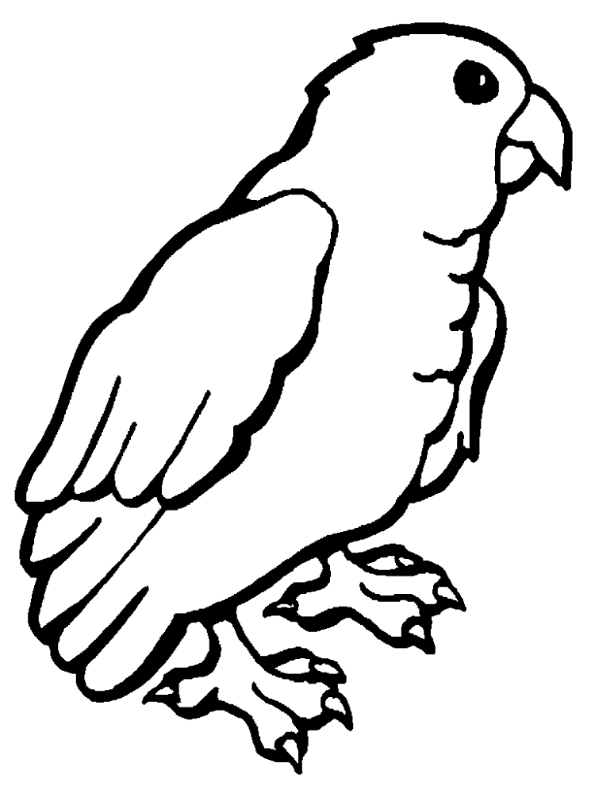
1
2 3

4 5

6 7

1
2
3
4
5
6
7

Mamiferos

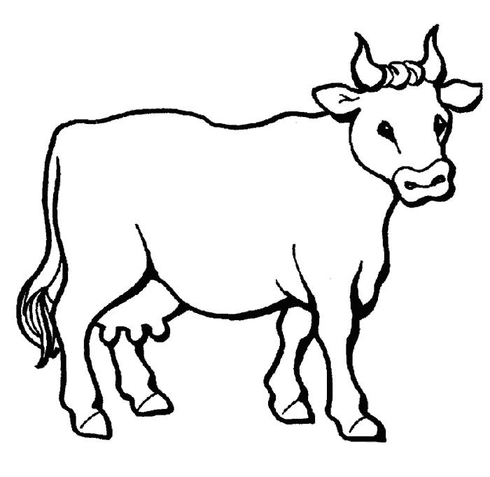
1
2

5

2

4

3

6 7

8

Reptiles
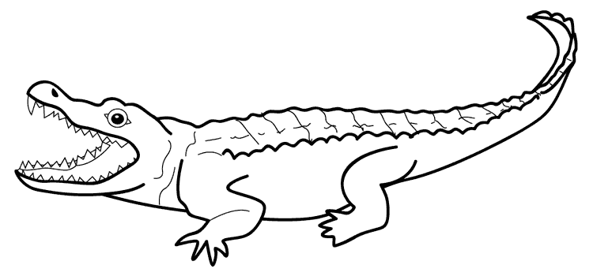

- 2
3
4

5

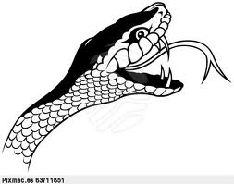

6

7

Peces

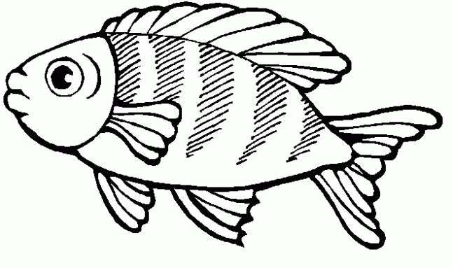
1

2 3 4

5 6

Insectos

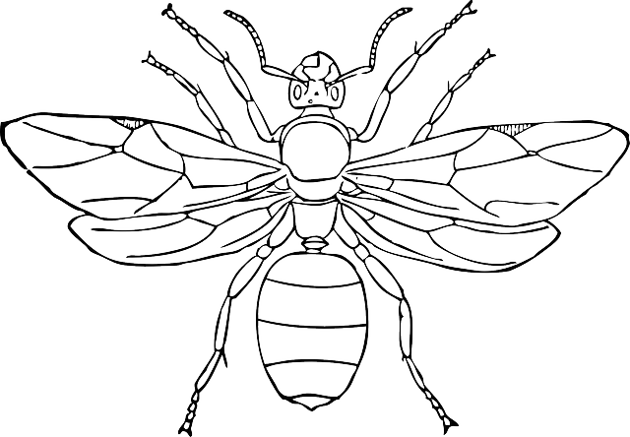
1 2

3
4

5

Arácnidos
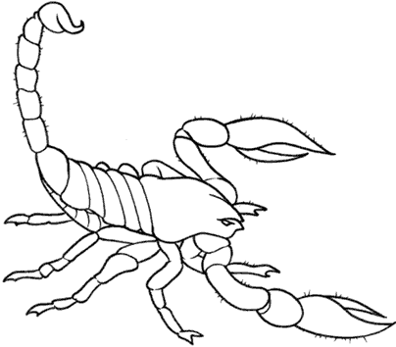
1

2
3

4

5

2. Create a power point presentation with the picture of the twenty animals you have selected for the test you will take Friday.
Each slide must contain the sentence you created on Nov 5

