Ar, ER, IR Verbs. Diciembre 4/2013

Go this link
http://espanolisto.jimdo.com/aprende-con-nuestros-temas-gratuitos/presente-del-indicativo-verbos-irregulares/
1 listen to the song then fill in the blank putting the verbs in the correct form. Copy and paste the song in a word document.
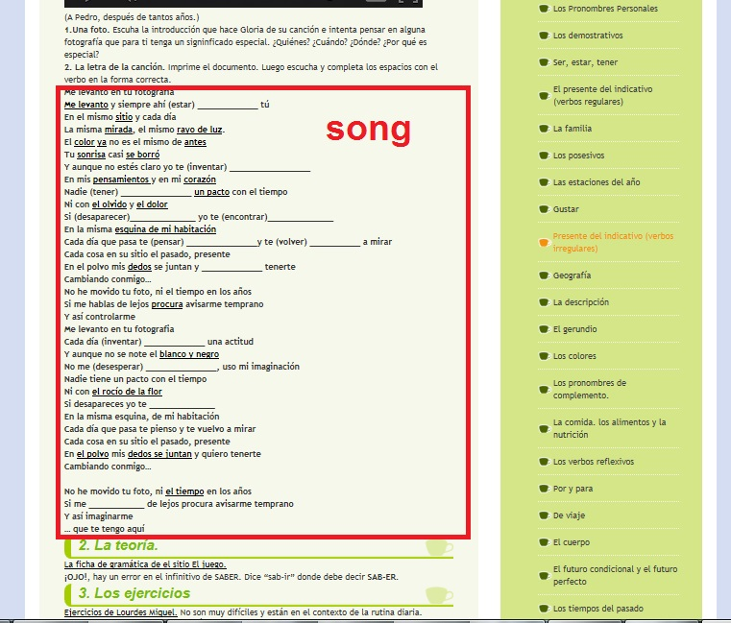

2. Do the exercises marked in the red box. Copy and paste the answers in a word document and submit them.
