Diciembre 3 de 2013
AR, ER , IR EXERCISES
Go to this website and work with the links in the green boxes.
http://www.aprenderespanol.org/verbos/presente.html
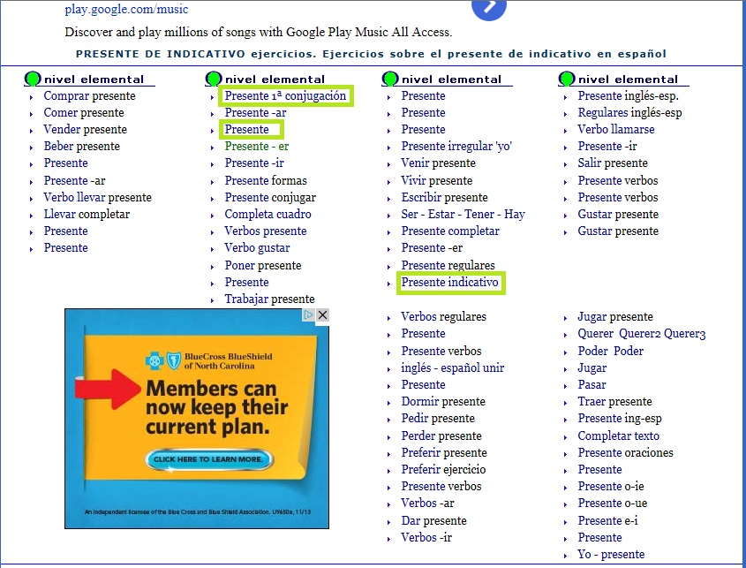

This video clip explains the Simple present Tense.
http://www.youtube.com/watch?v=a1Cjj-piLho

Go to this website, scroll down and look for . 3 Los ejercicios and do the exercise highlighted in the green box. Ejercicio 1.
http://espanolisto.jimdo.com/aprende-con-nuestros-temas-gratuitos/presente-del-indicativo-verbos-irregulares/

