Las profesiones y oficios
Professions and jobs

- Abogado
- Agricultor
- Albañil
- Carpintero
- Periodista
- Cirujano
- Ejecutivo
- Odontólogo
- Policía
- Arquitecta
- Ingeniero
- Maestro
- Cocinero
- Bombero
Create a power point presentation or a Microsoft Word Document.
- First look for a picture for each profession,
- Type the following sentence below of each picture.
- Fill in the first blank with the place where the person works and in the second blank with the tool that the person uses to perform the job. (14 slides)
El abogado trabaja en ___________ y usa________
profession works at Place and uses tool
ocervera@neusecharterschool.org

For example:
Abogado=Lawyer
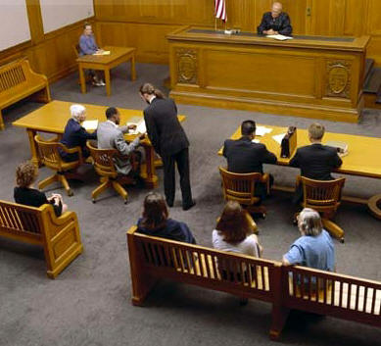
El abogado trabaja en la corte y usa el computador
The lawyer works at the court and he uses the computer

